Parallel Workflows in LangGraph
We are calculating strike rate, runs in boundary percentage, and balls per boundary give the total runs, balls, 4s and 6s.
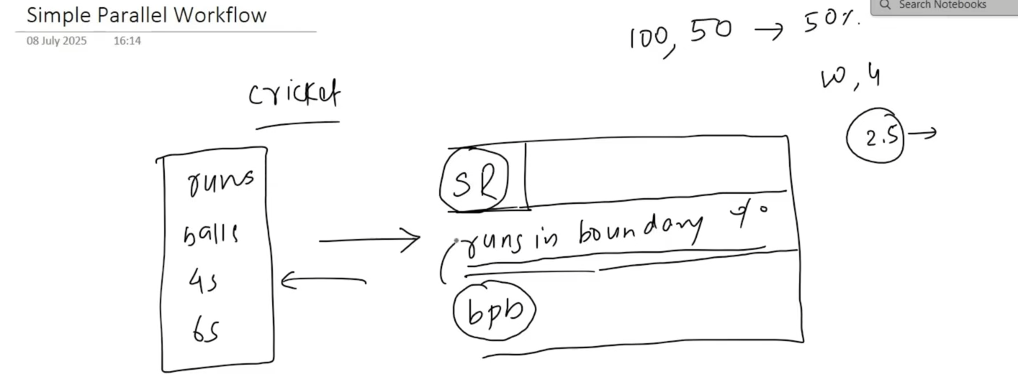

This is gonna be the workflow.
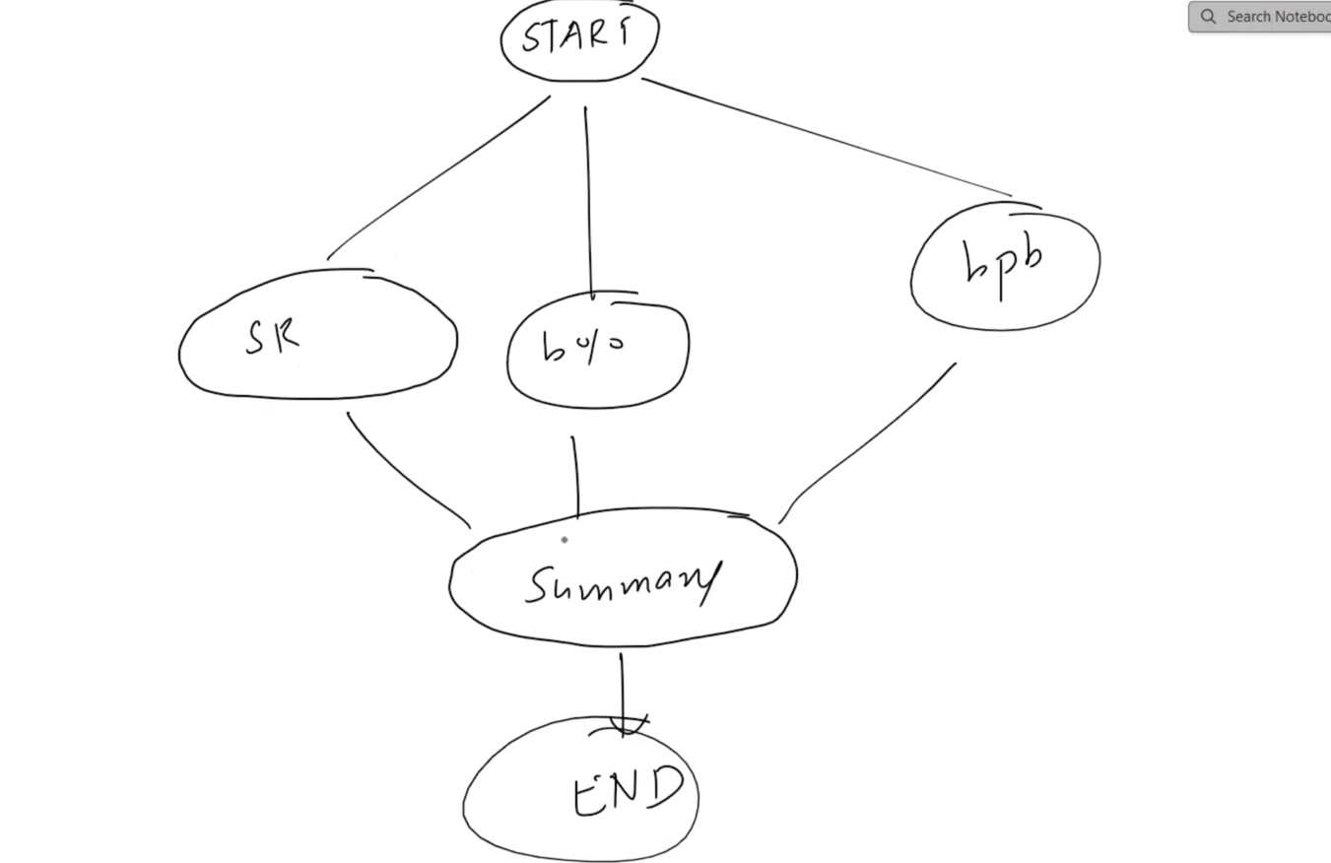
Code:-
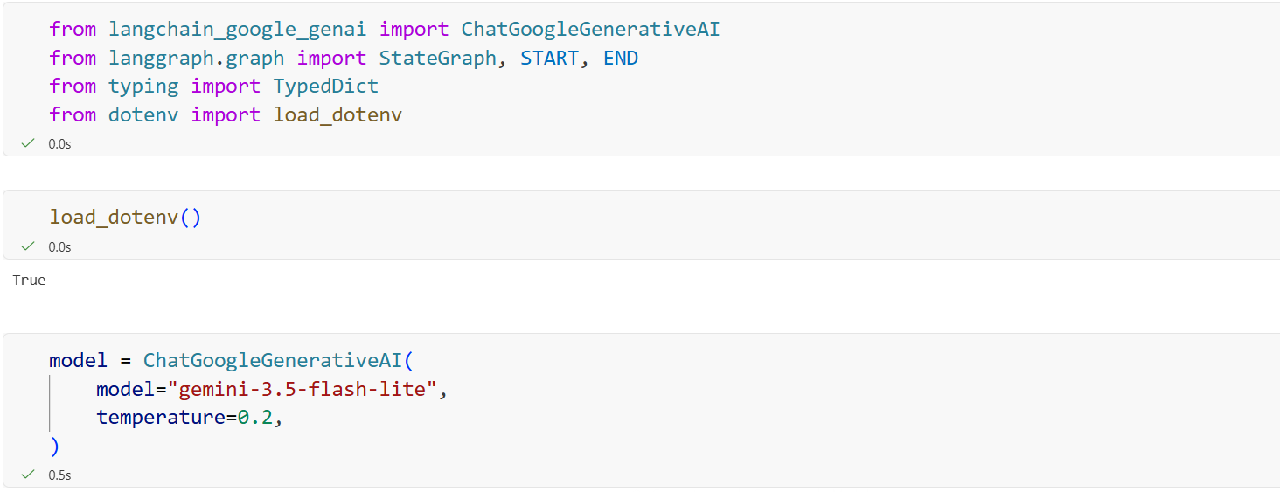
Now here the BatsmanState is normal as expected but calculate_str function is returning only partial state rather than entire state and that is because in parallel workflow, its necessary to do it otherwise when we combine them later and give it some other node. The node will be confused what to take even though all parallel nodes worked on different varaibles. It’s the same case with all the nodes in parallel. All of them sends only partial state back, the state they changed themselves.
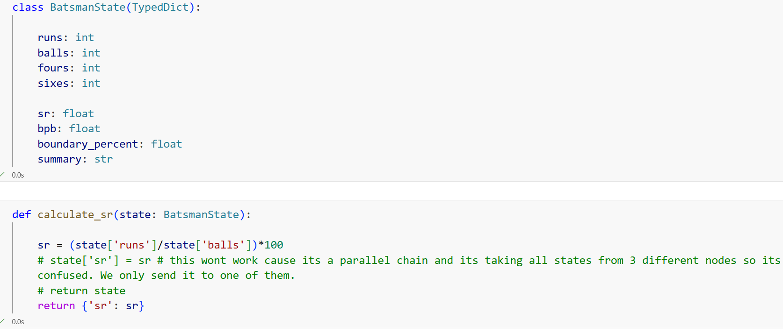
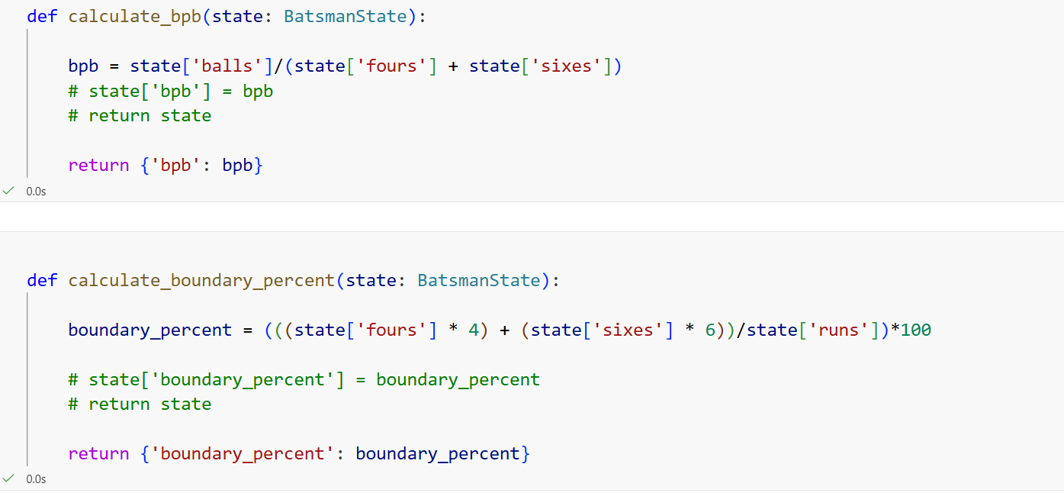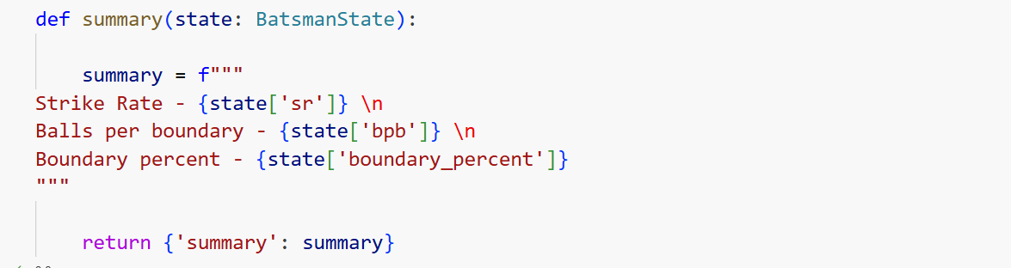
There are changesin edges. Since we are parallel, we do START with three nodes. We also give values of state from these nodes to the summary node.
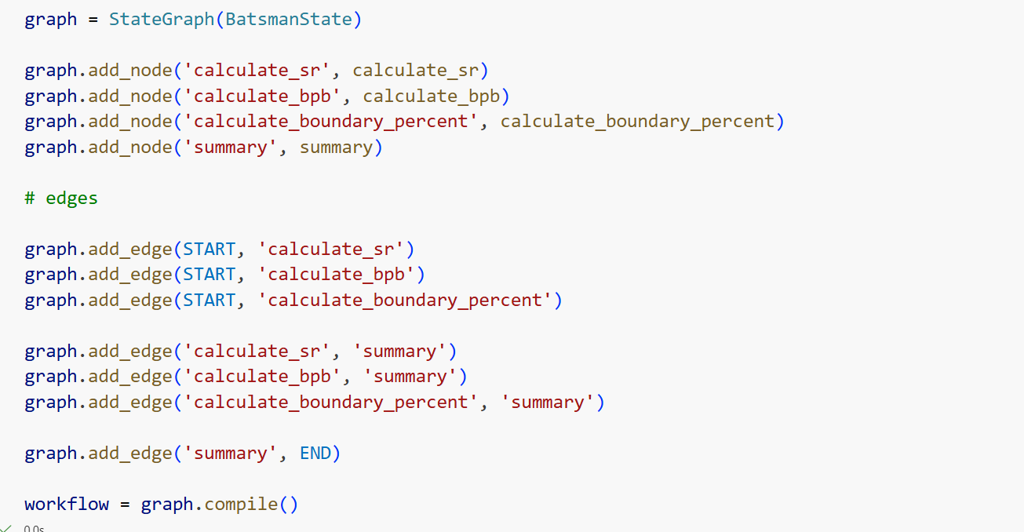
This partial returning of state works for both sequential and parallel but not the other way around.

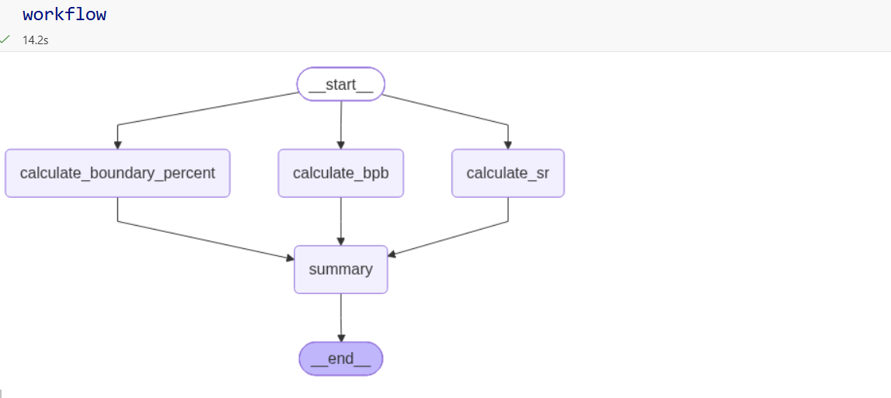
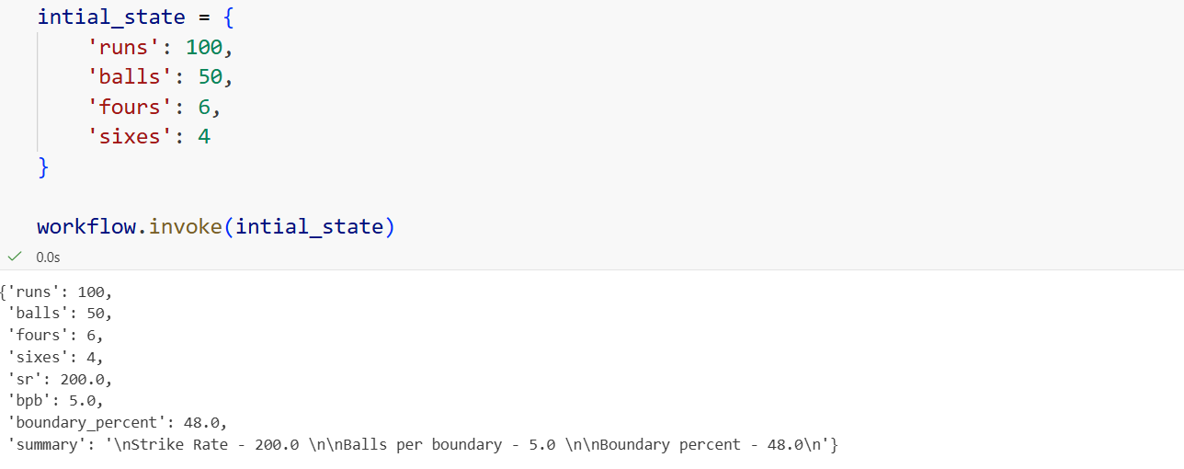

We give an essay and it evaluates it on 3 different scales and gives a score which then goes into final evaluation to give us final result.
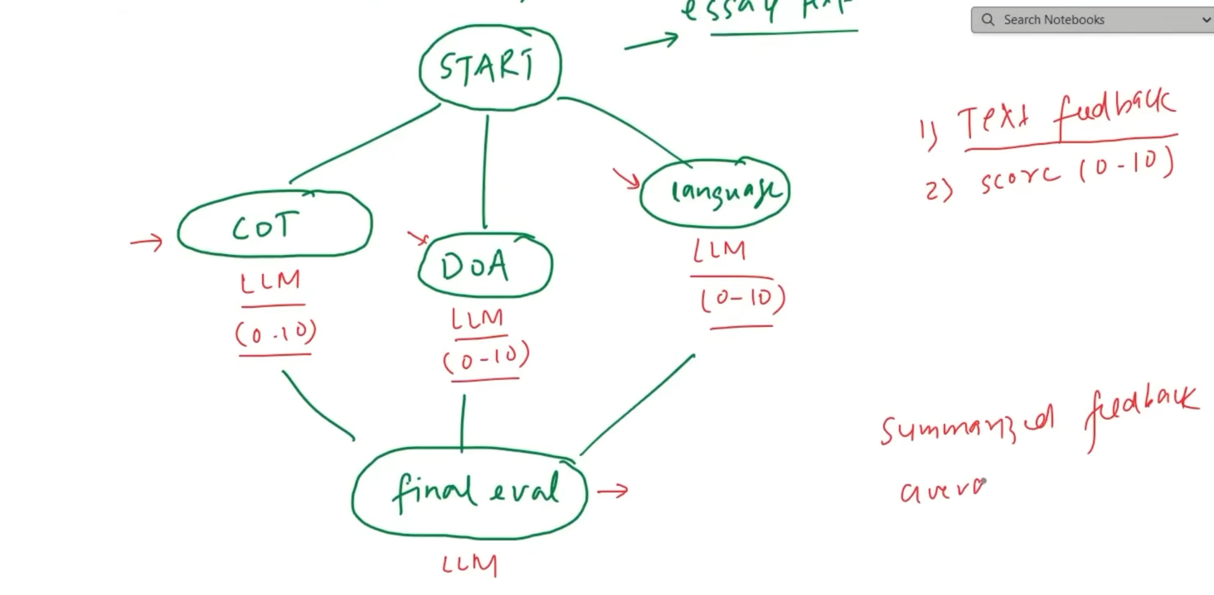

Code :-
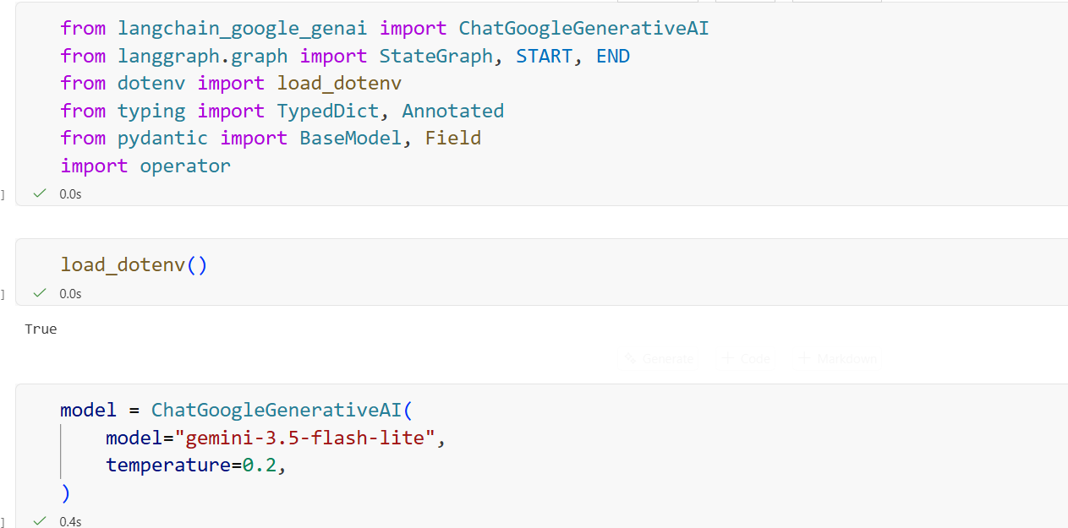

We wanted the score between 1 to 10 in integer so created a schema for that. Now if we invoke structured_model then we will get answer in this format.
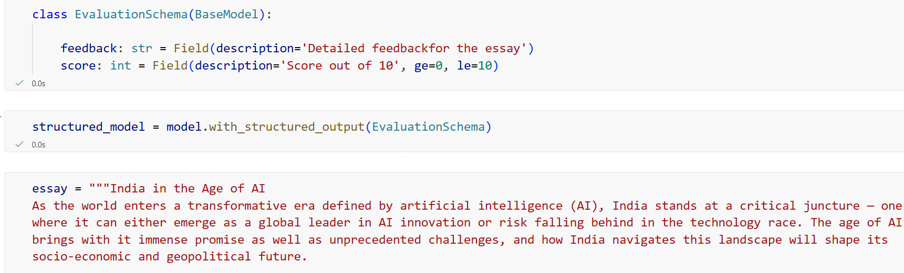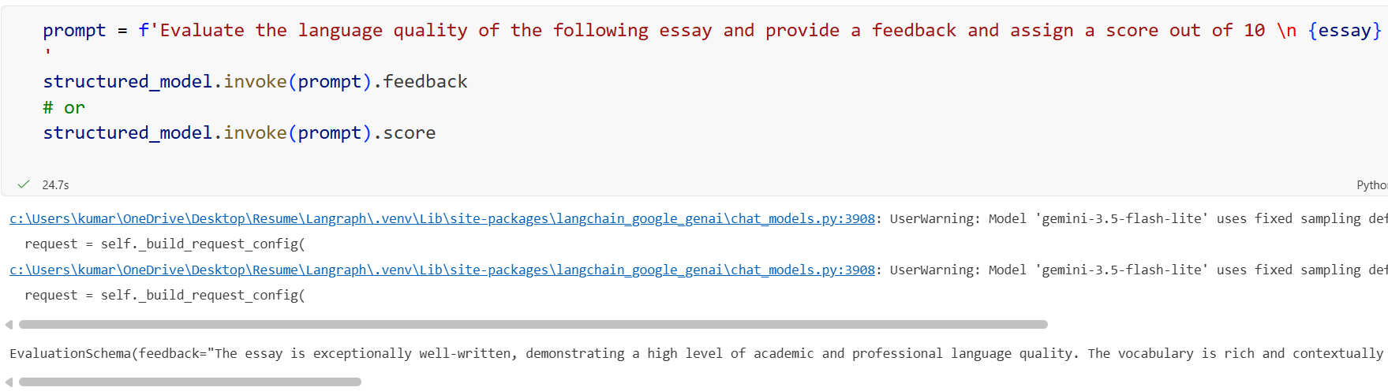

We have to add the elements in the list for all three values. We don’t want it to replace each other so we created three lists and then combined them. individual_scores is a list of integers, and operator.add tells LangGraph to combine the lists from multiple nodes instead of replacing them.
Intuition: Multiple nodes contribute scores → lists are added together
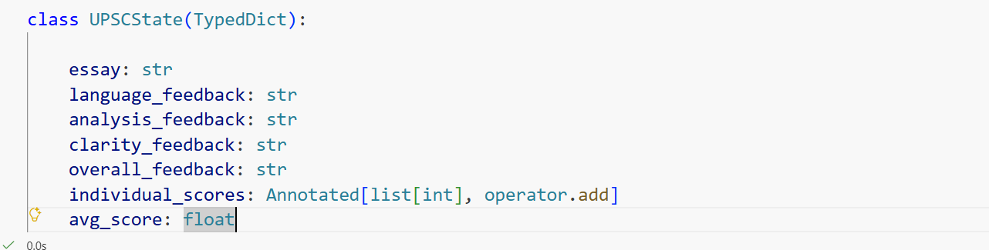

Here used structured_model to get an ouput so the response is in the format we defined in schema. We then returned both feedback and the score.
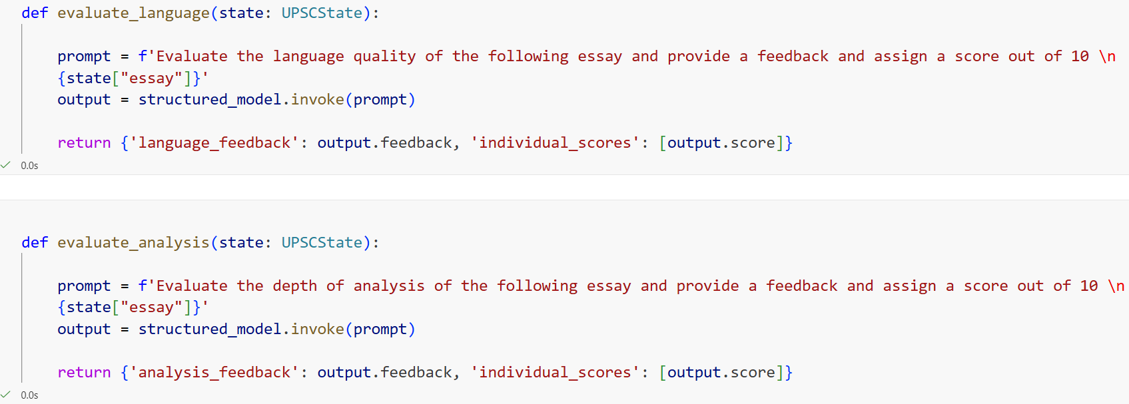

We didn’t need any structured output for final_evaluation so we just used normal model to get a text output and manually found the average of all three scores from the list rather than asking the LLM to do that. We then returned both overall feedback and the average score.
